# Lab: Java Syntax

Problems for exercises and homework for the [“Java Advanced” course @ SoftUni](https://softuni.bg/courses/programming-fundamentals).

You can check your solutions here: <https://judge.softuni.bg/Contests/382/Java-Syntax-Lab>.

# I/O and Data Types

## Read Input

Write program that reads:

* **Two strings** from the first line
* **Three Integers** which may be on multiple lines
* A **string** from the next line

Print the output in the following format **{firstWord secondWord thirdWord sumOfNumbers}.**

**The sum of numbers should be an integer.**

### Examples

|  |  |
| --- | --- |
| **Input** | **Output** |
| Java Rocks  5 12 -7  End | Java Rocks End 10 |
| scanner system  1 2 3  in | scanner system in 6 |

### Hints

* Use the Scanner class
* Use the methods **next()**, **nextInt()**, **nextLine()**

### Solution

You might help yourself with the code below:

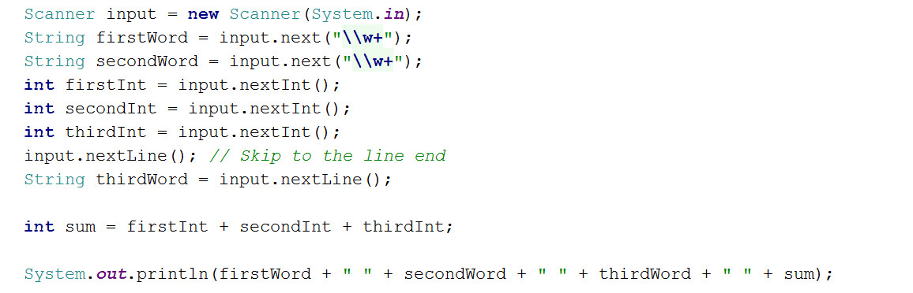

## Average of Three Numbers

Write program that **reads three numbers**. Print the **average of the three**, formatted to the **second digit after the decimal point.**

### Examples

|  |  |
| --- | --- |
| **Input** | **Output** |
| 2 4.5 3 | 3.17 |
| 3.1 4 15 | 7.37 |

### Hints

* You might use Scanner class
* To read the next double use the method **nextDouble()**:



## Euro Trip

You need to calculate the price of a given quantity of "wurst" in Deutsche Marks. Read the quantity as a double value and print the price in marks, given the following:

* The price of 1 kg wurst is 1.20 BGN
* The exchange rate is 4210500000000 DM : 1 BGN

Print the price, rounded to the second digit after the decimal separator.

### Examples

|  |  |
| --- | --- |
| **Input** | **Output** |
| 2.35 | 11873610000000.00 marks |
| 1 | 5052600000000.00 marks |
| 15 | 75789000000000.00 marks |

### Hints

* Use the BigDecimal class to handle calculations involving money
* You can format the output using:



## Greeting

Read first and last number as an input. Print a greeting starting with "Hello" where if a name is missing, replace it with five stars "*":

### Examples

|  |  |
| --- | --- |
| **Input** | **Output** |
| Robert  Ford | Hello, Robert Ford! |
| Ford | Hello, ***** Ford! |

### Hints

* Use the Scanner method **nextLine()**
* Use the String static method **isEmpty()** as in the example below:

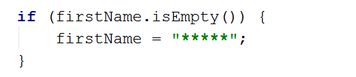

# Conditional Statements, Loops and Methods

## Transport Price

A student travels **n** kilometers using only **one type of transport** based on the **distance that he will travel**:

* **Taxi**: Initial tax: **0.70 USD**. Daytime cost: **0.79 USD/km**. Night time cost: **0.90 USD/km**.
* **Bus**: Day / Night tariff: **0.09 USD/km**. For **at least 20 kilometers**.
* **Train**: Day / Night tariff: **0.06 USD/km**. For **at least 100 kilometers**.

Write a program that calculates the price of the trip by a given distance and time of day.

Format the output to the second digit after the decimal separator.

### Examples

|  |  |
| --- | --- |
| **Input** | **Output** |
| 5  day | 4.65 |
| 7  night | 7.00 |
| 25  day | 2.25 |
| 180  night | 10.8 |

## Numbers 0..9

Using a while loop, print the numbers from 0 to 9 inclusive.

### Examples

|  |  |
| --- | --- |
| **Input** | **Output** |
|  | Number: 0  Number: 1  Number: 2  Number: 3  Number: 4  Number: 5  Number: 6  Number: 7  Number: 8  Number: 9 |

## Product of Numbers [N..M]

Write a program that calculates the product of all numbers in the interval [**n**..**m**] by given **n** and **m**:

### Examples

|  |  |
| --- | --- |
| **Input** | **Output** |
| 1 5 | product[1..5] = 120 |
| 3 20 | product[3..20] = 1216451004088320000 |

### Hints

Use the **BigInteger** class to handle big numbers and a do-while loop.

## Lottery

Print all combinations from TOTO 3/10 lottery (like 6/49 but with less combinations):

### Examples

|  |  |
| --- | --- |
| **Input** | **Output** |
|  | ...  ...  7 8 10  7 9 10  8 9 10 |

### Hints

Use 6 nested loops.

## Calculate Triangle Area Method

Create a method that calculates a triangle area by a given:

* Base
* Height

Return the area as an output of the program. Format the result to the second digit after the decimal separator.

### Examples

|  |  |
| --- | --- |
| **Input** | **Output** |
| 4.00 2 | Area = 4.00 |
| 3 6 | Area = 9.00 |